**P1– Deconstruct the design of three games**

**Mirror’s Edge**Mirror’s Edge is a first-person free-running/parkour game set in a dystopian future. It was developed by DICE studios and published by EA in 2008.

**Gameplay**Mirror’s Edge is a first person game, meaning that the game is seen through the character’s eyes. The player controls Faith, the protagonist of the game. The game has a single-player campaign, although there is an element of multiplayer as players can share race times and compete to get to the top of the leader board.  
The game is set in an unnamed ‘utopian’ city, usually referred to as ‘The City’ (although it may be called the City of Glass, as it is in the games reboot, Mirror’s Edge: Catalyst). The year is never specified, although it is likely around 2020 or later.  
The City, while seemingly utopian with virtually no crime and a perfect environment, is under a totalitarian regime, in which all aspects of citizens lives are known to the government.  
To combat this regime, a group of free-runners, known simply as the ‘Runners’, act as couriers to deliver messages across the city. They deliver messages in person, using parkour to traverse the upper levels of the city and get to their destination without being spied on.  
The goal of each level is to use free-running to get to a destination, without being killed by the police or falling to death. There are also three ‘Runner bags’ to collect in each level.  
The player can also complete time trials, in which they must run through a watered-down version of a level as fast as possible. This unlocks extra content, such as artwork and insights into the development of the game.  
The gameplay is centred around free-running (or parkour). The first-person perspective is designed to be immersive and realistic, so there is no HUD (heads Up Display, or information displayed on the screen overlaying the game world), and the Faith’s body is visible in-game. When she does a forward roll, the camera rolls a full 360° too. This level of realism can cause motion sickness in some players.  
Falling too far or being shot makes Faith move slower, and eventually the scene turns grey and red around the edges when Faith is severely injured, similar to how people who have almost died describe their vison fading.  
The player has the option of using ‘reaction time’, in which pressing ‘R’ will cause time to slow down for five to ten seconds, giving the player time to react to threats or stick a landing.  
Momentum is an important aspect of the moving. The longer Faith runs in a straight line, the faster she gets, she breaths faster, her strides get longer, the camera bobs faster, her arms pump faster, and she is able to jump and slide further. However, turning, bumping into something or fighting an enemy reduces momentum, making it harder to traverse obstacles.  
Faith can run, strafe and walk backwards, as well as jumping (distance depends on momentum), climb pipes and ladders, and swing from flagpoles or overhead pipes. The controls are context sensitive – for example, left-clicking will make faith punch if an enemy, wall or nothing is within range, but will open doors or pick up a gun if they are in range. Similarly, the space bar will always cause Faith to attempt to go up – be that jumping, climbing, wall-running or vaulting, depending on what is in front of her. The shift key is for downwards movement – crouching, sliding under, or rolling, again depending in what is around her.  
Faith can pick up guns to shoot enemies, but this prevents her from building momentum, making moving extremely difficult. This discourages shooting, and encourages players to keep moving and not stop, dodging enemies rather than confronting them.  
The combat system is mostly melee. Faith can punch, low punch, kick, low kick, or jump feet-first onto enemies. The damage of the attack depends on her momentum, so standing in front of an enemy and hitting them will do almost nothing, but running full speed and jump-kicking them will knock them out.  
The player can also grabs enemy weapons with careful timing, although in the frenzy of an unbalanced fight the player usually forgets the combat system and either runs away or just uses every attack randomly as fast as possible, despite this being the least effective method of attack.  
A level is complete when Faith reaches her destination.  
The game gets progressively harder with each level, and harder throughout the individual levels too. For example, the first level is fairly easy, it is clear where to go and there are no enemies. However, about halfway through, Faith encounters police, and must escape run away. At this point, stopping to assess the situation becomes near-impossible, as the player is being shot at.  
In later levels, almost no indication of the correct route to the destination is given, and the number of enemies increases.  
Although the campaign only lasts about 12-15-hours, the gameplay is trial and error as players must figure out the correct route and Faith is usually killed whilst the player tries to figure out where to go while being shot at.  
The levels are highly re-playable, as they are same every time, and trying to complete the level as quickly as possible is considered a secondary objective.  
Players can then also compete to beat each other’s times.  
The game has a few NPC’s, such as other characters who are part of the storyline, and enemies, mainly the police.

**M1**The art style of the game is somewhat minimalistic. The colour pallet consists almost entirely of white, red, black, green, blue and brown, with very little other colour, although the game still has highly detailed textures, ambient lighting and occlusion, particle effects, and looks almost photo-realistic. Many players say the game has incredible graphics for its age, better than even many newer games.  
The game was made using the Unreal 3 engine, with a bespoke lighting system. As the game is from 2008, now in 2016 it will run on medium settings on a mid-range laptop.Mirror’s Edge uses FMV’s, including cutscenes rendered in real-time, FPV cutscenes, and pre-rendered 2D animations.

**D1**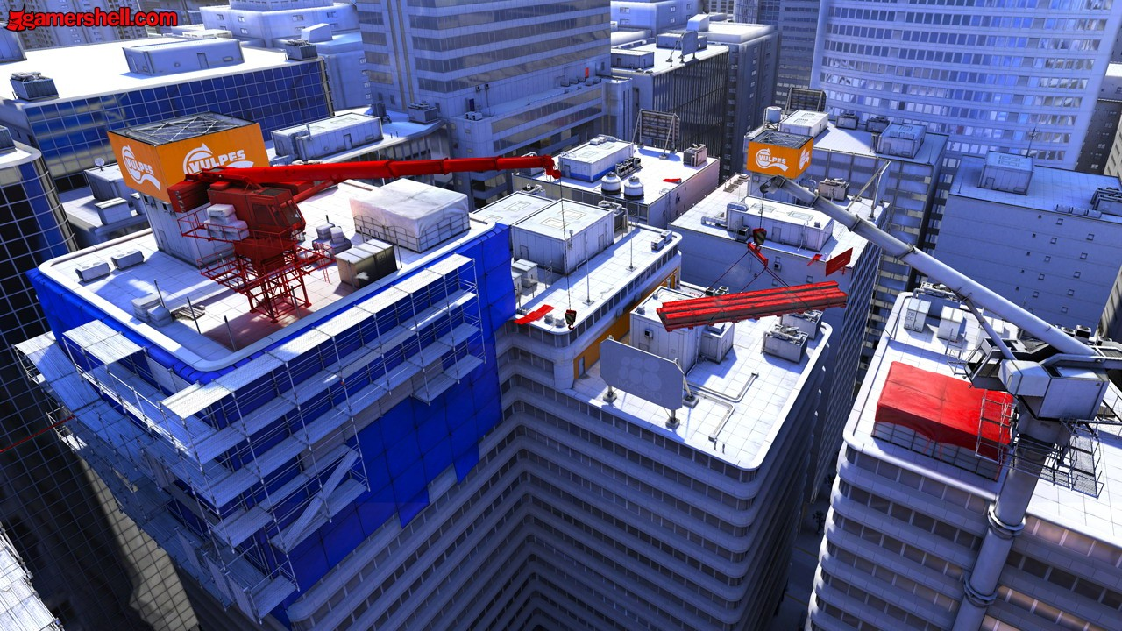

The picture above shows the aesthetic of the game well. The city is detailed and realistic, despite the simple colour scheme.  
However, as the game is over eight years old and used a last-gen game engine, it is unsurprising that some shortcuts were taken to ensure the game runs well. For example, the reflections in windows do not actually reflect what is in front of them, but are pre-designed textures that look ‘good enough’ if they are not scrutinized too closely.

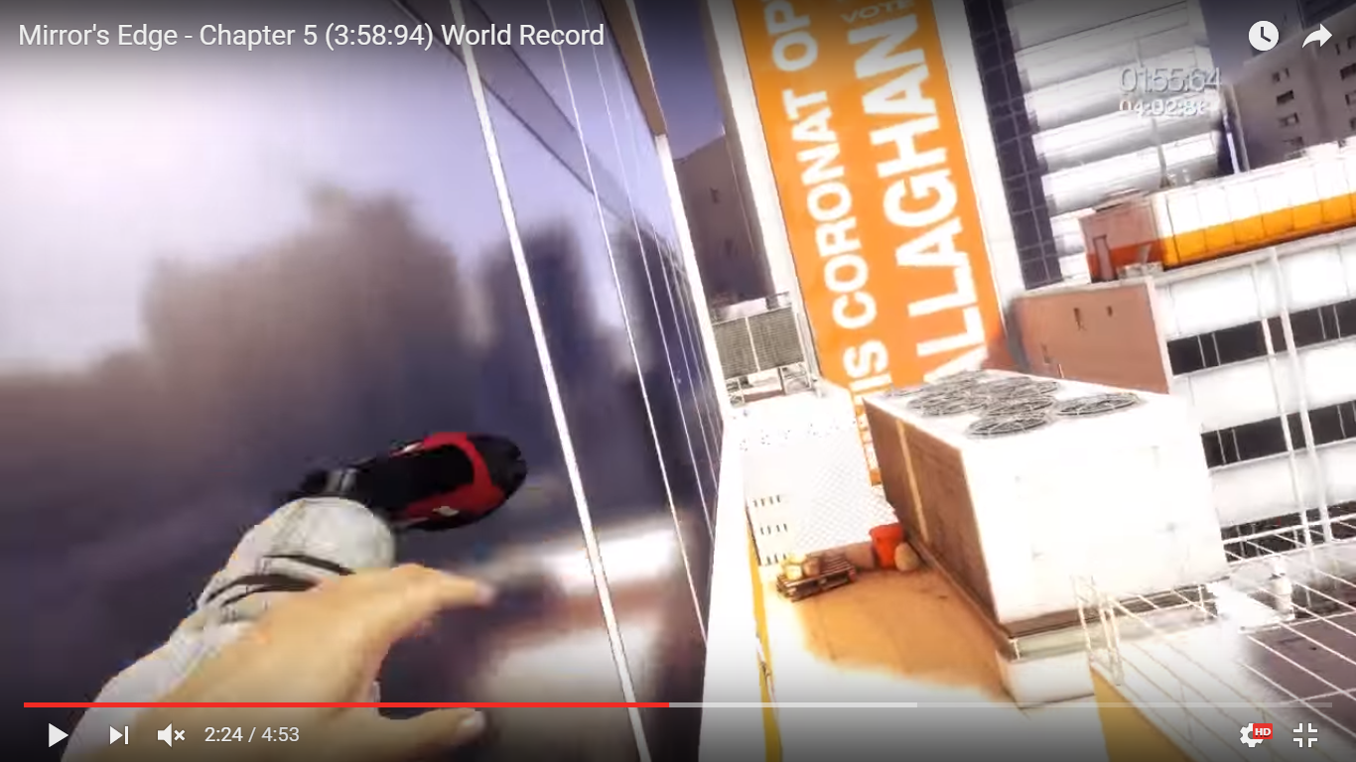

The reflection of Faith’s leg is missing!

**SUPERHOT**SUPERHOT is a minimalistic single-player FPS with a mechanic in which time in the game only moves when the player moves, transforming the game from a standard FPS to a time-bending strategy game. It was released in 2015.

**Gameplay**SUPERHOT’s main character is a fictionalized version of the player, sitting in front of their DOS computer. The storyline starts when a friend sends the main character a game called SUPERHOT.EXE, saying it is an illegal download.  
The menu screen is an emulation of a DOS computer, with programs representing menu options. A lot of bonus material besides the main game is accessible, including ports of some ASCII DOS games.  
Upon selecting SUPERHOT.EXE in the menu, the game itself starts. The game takes place in a variety of minimalistic settings around a city, such as museums, train stations and apartments. Prompts or cryptic comments will flash onscreen and then the player must defeat the ‘Red Guys’.  
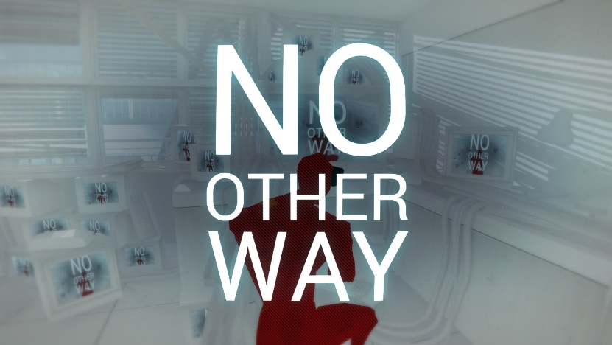  
If the player does not move, time is almost frozen – the Red Guys move towards the player at a glacial pace, and bullets crawl through the air in slow motion. However, as soon as the player *does* move, be it looking around, walking in any direction, jumping, attacking or picking up an object, time will speed up for as long as the player is moving. The Red Guys will attempt to attack the player, and although time is almost frozen, they can react at the same speed as the player, making them difficult to outsmart.  
The Red Guys will move towards and attempt to shoot or hit the player with weapons they pick up, including pistols, shotguns, rifles, swords, bottles and crowbars, among other things.  
The player sometimes starts with a weapon, or can pick them up. They can grab suitcases, phones, bags of rubbish and other items to throw at enemies. This will cause the enemy to drop their weapon, which the player can snatch out of mid-air if they are close enough.  
Bullets fired towards the player move forward very slowly whilst they are still, giving the player time to assess the situation and decide how best to dodge and put themselves in a tactically superior position. Upon moving, the bullets will speed up proportionally to the player, and enemies will keep shooting too.  
The player can shoot back, but the act of pulling the trigger causes time to briefly speed up, and the player’s bullets will also move slowly whilst time is slowed, so the Red Guys are also able to dodge the bullets. Once the bullet has left the chamber, the player cannot fire again until the gun has reloaded, which takes almost a minute if they do not move.  
Different weapons have different effects – throwing blunt objects will merely stun an enemy and disarm them, while sharp objects and bullets will kill them. Guns eventually run out of ammo, at which point they can be thrown at an enemy. Upon death, the enemies shatter into pieces and disappear. However, any form of attack from an enmey will kill the player in one hit, regardless of the weapon.  
New enemies occasionally run in from the walls or glowing portals, meaning the player must be aware of threats from any direction, as they could be shot from behind while dodging a bullet from in front.  
There are various stages in each level where another prompt or message will flash up on screen, usually after destroying a certain number of enemies. These tend to be puns on the situation. For example, in a level set on a moving train, the message might be “THIS IS YOUR STOP”.  
The level completes when all of the enemies have been defeated, usually 7-12 of them.  
If the player dies, the level restarts. The player can restart the game anytime they want.  
In-between levels, the main character keeps receiving threats from the creator of the game, insisting they stop playing. At one point, the player must actually restart the game in order to continue. Eventually, the main character is unable to control their own actions, and becomes stuck in the game.  
The primary focus on gameplay style is to recreate the feel of slow-motion action scenes from movies, dodging bullets and defeating enemies in the most efficient, rapid-fire way possible. However, it is possible to play at normal speed by constantly moving.  
Levels are exactly the same every time they are replayed, and it often requires trial-and-error to memorize the order and position of enemies, trying different actions each time to complete a level.

**M1**  
The game has an extremely minimalistic art style, with only three colours – white, black and red. The developers said that this is to help the player focus and better understand the scene. The environment is white, anything the player can interact with, such as a weapon or object they can pick up and throw, is black, and the enemies are red. Although the game is entirely first-person, what can be seen of the main character, such as his hands, is black.  
Only the bare minimum of the setting is present. Anywhere the character cannot go is simply not there – such as the other side of a fence of the view beyond a window.  
The environment, while simplistic, is fairly realistic in its dimensions, but the player and enemies look like glass shop dummies (they shatter when killed too), all angular edges, no curves, and no details beyond a humanoid shape.  
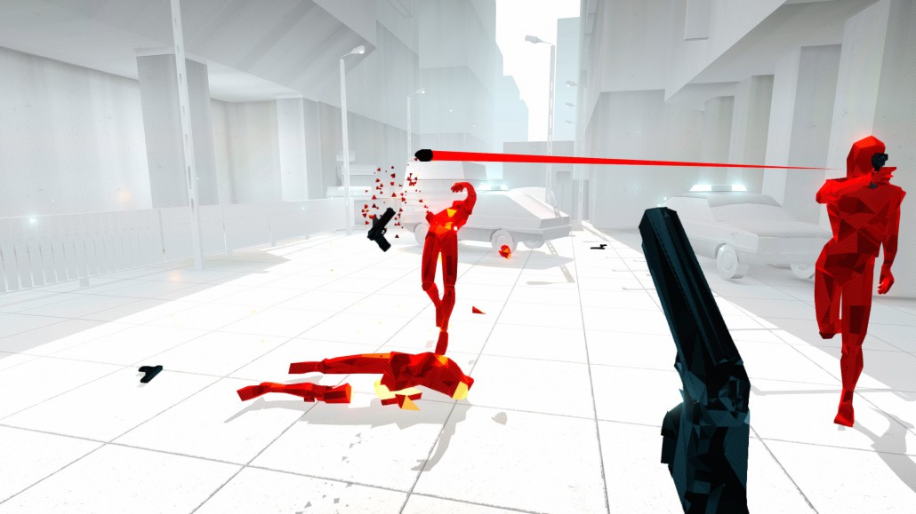  
Due to the small level maps and incredibly simplistic visual style, the game is very lightweight – it is a 2.5GB download, as opposed to the 20GB+ downloads of many other FPS games. It also has low minimum specifications to run, and does not need a particularly powerful GPU or processor, although a fast hard drive reduces the loading times considerably.  
The game uses what could be considered as FMV, as in-between levels the creator of the game gives messages on screen, during which the player has no control, even when asked to type something – the response the character types in-game does not correlate to which keys are actually pressed.

**D1**As the ‘Time only moves when you move’ mechanic was integral to the game, it is extremely well done and works well. There is no lag or stuttering, and the speed is proportional to the movement rather than being stop-start.  
However, as the enemies have the same perception of time as the player, it is very difficult to catch them off-guard. Even though the level only lasts 3-4 seconds of in-game real time, the enemies can still react at the same speed as the player, so a huge advantage is lost. This can make completing a level very difficult and frustrating.  
This could be improved by making the enemies react in real-time rather than at the same speed as the player, or having a setting for this.  
Also, although enemies can kill the player in one hit, regardless of weapon (while the player has to punch three times and can only stun enemies by throwing things at them), the combat feels a little unfair.  
However, the game is a puzzle-shooter, so it is not intended to be easy, and it presents a challenge.  
Also, the time mechanic makes multiplayer impossible, as the flow of time is dependent on the players movement, so having more than one player wouldn’t work.

**Alien VS Predator (2010)**  
Alien VS Predator (usually referred to as AvP) is an FPS horror/action game (based on the Alien VS Predator movie franchise) developed by Rebellion studios and published by Sega in 2010.

**Gameplay**AvP is entirely first-person, and has three different campaigns and a multi-player mode. The story revolves around the conflict between three different species – Humans, Aliens (Xenomorphs) and Predators (the Yautja). Each campaign takes place concurrently in the story, but from the perspectives of different characters, and so the player can play as each of the three species, which have different objectives and abilities. Players can also play as any of the species in multiplayer mode.  
Each level of the game has a simple objective – usually to reach a destination or kill all of the enemies in a level, sometimes both.  
The campaign takes place on another planet, where the aliens have escaped from a research facility, the humans are trying to wipe them out, and the predators are hunting aliens and humans alike for sport.  
In order to better understand the gameplay, it is important to know the three species, as game mechanics vary between them.

|  |  |  |  |
| --- | --- | --- | --- |
| Species | Unique abilities | Strengths | weaknesses |
| Alien | Fastest species, can climb on any surface, see through walls, and blend into darkness. | Can hide in shadows, go to areas of the maps other species can’t, one-hit kill and always see other species. | Has least health, can’t carry weapons. Takes an extreme amount of skill to control. |
| Predator | Has different vision modes to see humans and aliens, can turn invisible and can jump very far. | Has access to very powerful weapons, can see humans and aliens regardless of camouflage, can turn invisible | Can only see one species at a time with vision modes, does not have all weapons by default, can still be seen by alien even when invisible. |
| Human | Has the most powerful weapons. | Can kill other species at long range. Has the most health. Has motion tracker to warn of enemies. | Cannot see invisible predators or hiding aliens, has little close-up defence. |

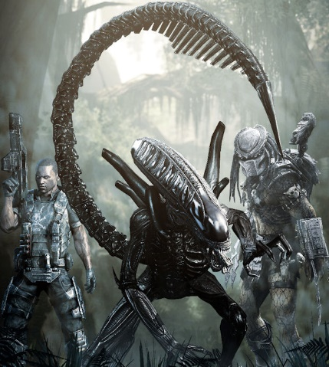

Promotional artwork showing all three species.

The three species have been very carefully designed to ensure they are balanced and combat is fair, which is especially important to ensure an all-round enjoyable game, and that multiplayer matches do not become one-sided. In addition, being able to play as any species is one of the game’s biggest selling points. It also ensures that gameplay is always varied and does not become stale.  
Playing as the humans is a horror-survival game, in which the player must carefully navigate claustrophobic environments, with terrifying looking (and sounding) aliens leaping from the shadows.  
Playing as the predator is more of a standard RPG style experience, in which humans pose little-to-no threat (if dealt with correctly), and aliens are a fun challenge to defeat.  
When playing as the Alien, the game becomes a reverse horror-survival experience - the *player* is the monster, able to sneak up on NPC’s and other players.

**M1 & D1**The game uses a proprietary game engine, but makes use of DX9 and 11. The textures are generally flat-looking and somewhat muted, making inspecting things up close a strange and uncomfortable experience (as the textures simultaneously look 2D and 3D), but the ambient occlusion, animations, lighting and other effects make a very realistic graphical experience, particularly as the game generally has a dark and moody colour scheme.

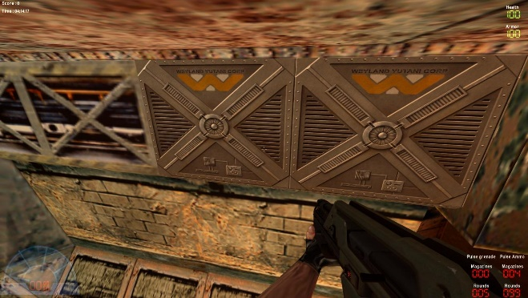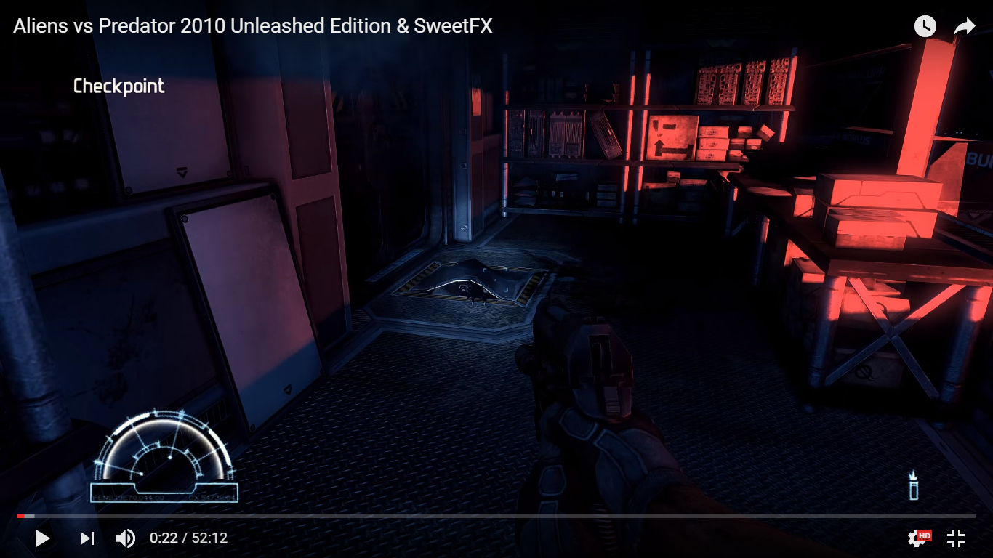  
Possibly the most interesting aspect of the game is the variations between the FOV’s of the different species. The alien, capable of sprinting very fast and transitioning effortlessly from floor to wall to ceiling and anywhere in-between, is often very disorientating for players, as the camera rotates in every direction at high speed. The alien also has an 88° FOV fisheye style view, enhancing the bizarreness of this perspective. It takes an incredible amount of skill to control the alien due to its sheer speed and the fact that most of the time it’s upside down.  
The predator has a detailed HUD, targeting systems and different vision modes to make different species more visible.  
The human gets the most normal-looking view, with just a few bits of information in the corners, such as ammo, health and the motion tracker (showing the location of movement, particularly aliens).  
Despite being a console port, the game is fairly well optimized, with no framerate limit and it does include advanced graphics settings. However, it does not include some options usually deemed essential in first-person POV games, which is the Field-Of-View (FOV), which is how much the camera shows, measured in degrees. 90° is standard for most games, with FOV’s as low as 70° for console (as players are generally sitting further from the screen) and 100° for extra immersion (or a tactical advantage) on PC. In AvP the Marine and Predator have 70° FOV’s and the Alien has an 88° FOV, which seems wide in comparison to the other two campaigns but on PC is still very narrow, meaning that playing on PC can be frustrating as you constantly have to turn to see things.